PLEASE JOIN US FOR A FREE SEMINAR
PRESENTED BY


“LANDlORD & TENANT RIGHTS”

Tuesday April 17, 2018
5:00 Pm-6:00 Pm

Amherst Town Hall
5583 Main Street (Council Chambers)
Williamsville, NY 14221

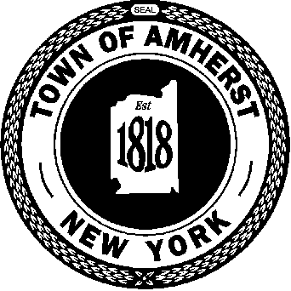
ECFHP, Inc.

To register please contact
(716) 631-7053

